

Daffodil International University (DIU)
Department of Computing Information System

Assignment On

Overall Condition/Decision Making Practice

Submitted To

Abdullah Bin Kasem Bhuiyan

Lecturer, Department of CIS

Daffodil International University

Submitted By

Md. Fuad Hasan

222-16-669

Date of Submission: 30-09-2022

1. Niloy’s basic salary is input through the keyboard. His dearness allowance is 40% of his basic salary and house rent is 20% of his basic salary. Write a program to calculate his gross salary.
Pseudo Code

Step 1: Declare variable (Father age, Mother age, Uncle age) to store integer value.
Step 2: Display the message to enter (Father age, Mother age, Uncle age);
Step 3: Taking output a variable (Father age, Mother age, Uncle age);
Step 4:
If (uncle>father && uncle>mother);
Step 5: Print output (“uncle is oldest person”);
Step 6:
If (uncle>mother && father>mother);
Step 7: Print output (“mother is youngest person”);
Step 8:
If (uncle>father && father>mother);
Step 9: Print output (“your father’s age between oldest and youngest age”);
Step 10: End

Flow-Chart

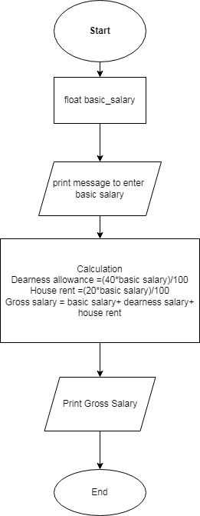

2. The distance between Mirpur and Ashulia is input through the keyboard. Write a program to convert and print this distance in meter, feet, inches and centimeters.

Pseudo Code

1. Declare variable (distance) to store fractional value.
2. Show message to enter (distance)
3. Taking input to variable
4. Calculation,
Meter=1000*distance
Feet=3280.84*distance
Inches=39370.1*distance
Centimeters=100000*distance
5. Print output meter
6. Print output feet
7. Print output inches
8. Print output centimeters
9. End

Flow-Chart

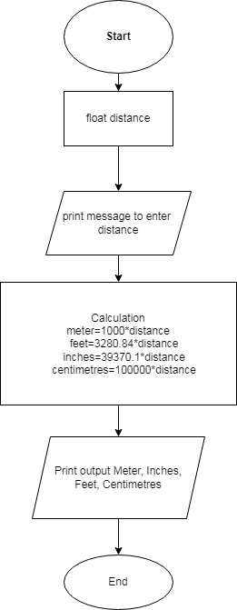

3. If the marks obtained by a student in five different subjects are input through the keyboard, find out the aggregate marks and percentage marks obtained by the student. Assume that the maximum marks that can be obtained by a student in each subject are 100.

Pseudo Code

1. Declare variable (sub_1, sub_2, sub_3, sub_4, sub_5, aggregate_marks, percentage_marks) to storage fractional values.
2. Show message to enter the marks of (sub_1_sub_2, sub_3, sub_4, sub_5, aggregate_marks, percentage_marks)
3. Taking input to variable (sub_1, sub_2, sub_3, sub_4, sub_5, aggregate_marks, percentage_marks)
4. Calculation
Aggregate_marks=sub_1+sub_2+sub_3+sub_4+sub_5
Percentage_marks= (aggregate_marks/500)*100)
5. Print output aggregate marks
Print output presents marks
6. End.

Flow-Chart

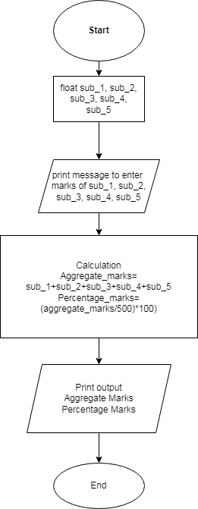

4. Temperature of a city in Fahrenheit degrees is input through the keyboard. Write a program to convert this temperature into Centigrade degrees.

Pseudo Code

1. Declare variable (City Temperature) to storage fractional value.
2. Show message to enter (city temperature)
3. Taking input to variable
4. Calculation,
Centigrade= (citytemperature_F-32)/9*5
5. Print output temperature into centigrade
6. End

Flow-Chart

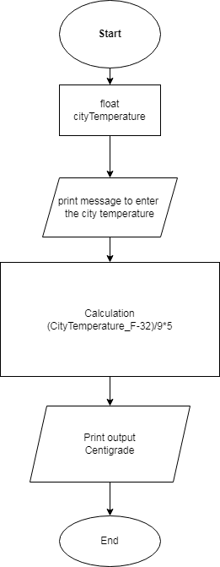

5. The length & breadth of a rectangle and radius of a circle are input through the keyboard. Write a program to calculate the area & perimeter of the rectangle, and the area & circumference of the circle.

Pseudo Code

1. Declare variable (length, width and radius) to store fractional value.
2. Display the message to enter (length, width and radius)
3. Taking input to variable
4. Calculation,
area rectangle=length*width
perimeter=2*(length+width)
area circle = PI *radius *radius
circumference=2*(length+width)
5. Print output rectangle area
6. Print output perimeter
7. Print output area circular
8. Print output circumference
9. End

Flow-Chart

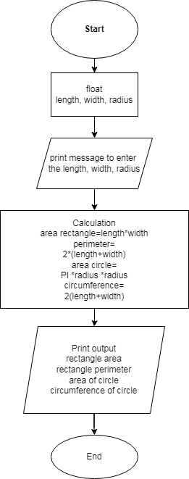

6. Two numbers are input through the keyboard into two locations C and D. Write a program to interchange the contents of C and D.

Pseudo Code

1. Declare variable (C, D, E) to store integer value.
2. Display the message to enter (C, D)
3. Taking input to variable
4. Calculation,
e = c
c = d
d = e
5. Print output, c
6. Print output, d
7. End

Flow-Chart

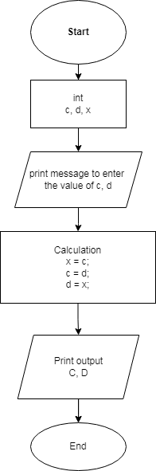

7. If a five-digit number is input through the keyboard, write a program to calculate the sum of its digits.

Pseudo Code

1. Declare variable (number) to store integer value.
2. Display the message to enter (number)
3. Taking input to variable
4. Calculation, e=num%10;
d= (num/10) %10
c= (num/100) %10
b= (num/1000) %10
a= (num/10000)
sum = a+b+c+d+e
5. Print output sum
6. End

Flow-Chart

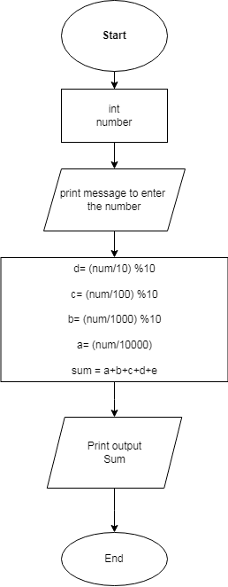

8. If a five-digit number is input through the keyboard, write a program to reverse the number.

Pseudo Code

1. Declare variable (number) to store fractional value.
2. Display the message to enter (number)
3. Taking input to variable
4. Calculation,
e=num%10
d= (num/10) %10
c= (num/100) %10
b= (num/1000) %10
a= (num/10000)
reverse= e* 10000 + d*1000 + c*100 +c*10 + d
5. Print output reverse
6. End

Flow-Chart

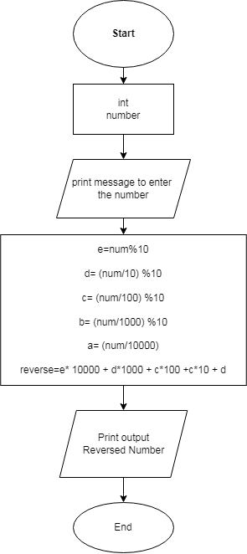

9. If a four-digit number is input through the keyboard, write a program to obtain the sum of the first and last digit of this number.

Pseudo Code

1. Declare variable (a, e) to store integer value.
2. Display the message to enter (a, d)
3. Taking input to variable
4. Calculation,
d=num%10
a= (num/1000)
sum= a+ d
5. Print output sum
6. End

Flow-Chart

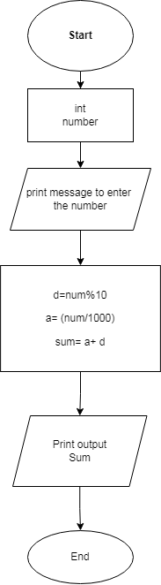

10. in a town, the percentage of men is 52. The percentage of total literacy is 48. If total percentage of literate men is 35 of the total population, write a program to find the total number of illiterate men and women if the population of the town is 80,000

Pseudo Code

1. Declare variable (town population) to store integer value.
2. Display the message to enter (town population)
3. Taking input to variable
4. Calculation,
men= (population*52)/100
women= population-men
men_and_women_literacy=population-men
men_literacy= (men*35)/100
men_illiteracy= men-men_literacy
women_literacy= men_and_women_literacy-men_literacy
total_literacy= population-men_and_women_literacy
women_illiteracy= total_literacy-men_literacy
5. Print Output total literacy
6. Print output women illiteracy
7. End

Flow-Chart

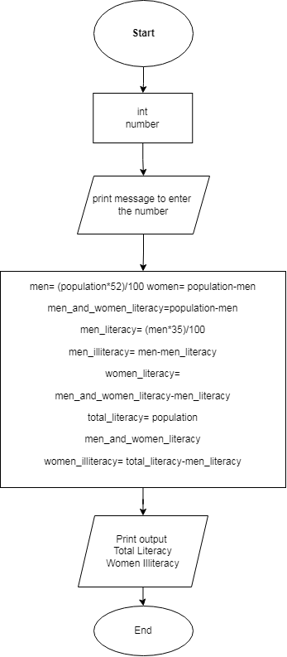
11. a cashier has currency notes of denominations 10, 50 and 100. If the amount to be withdrawn is input through the keyboard in hundreds, find the total number of currency notes of each denomination the cashier will have to give to the with-drawer.

Pseudo Code

1. Declare variable (currency) to store integer value.
2. Display message to enter (currency)
3. Taking input to variable
4. Calculation,
Hundred tk=amount/100
amount=amount%100
fifty_tk=amount/50
amount=amount%50
ten_tk=amount/10
5. Print output hun_tk
6. Print output fifty_tk
7. Print output ten_tk
8. End

Flow-Chart

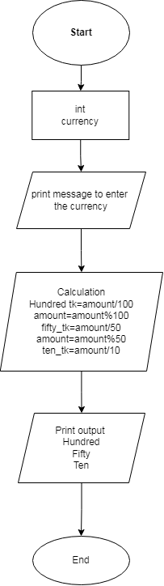

12. if the total selling price of 15 items and the total profit earned on them is input through the keyboard, write a program to find the cost price of one item.

Pseudo Code

1. Declare variable (total selling prize, total profit) to store integer value.
2. Display the message to enter (total selling prize, total profit)
3. Taking input to variable (total selling prize, total profit)
4. Calculation,
one_product=(selling_price - profit_earned)/15
5. Print output one product
6. End

Flow-Chart

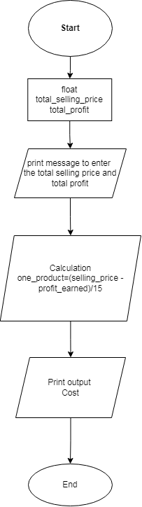

13. If a five-digit number is input through the keyboard, write a program to print a new number by adding one to each of its digits. For example, if the number that is input is 12391 then the output should be displayed as 23502.

Pseudo Code

1. Declare variable (number) to store integer value.
2. Display the message to enter (number)
3. Taking input to variable (number)
4. Calculation,
a= (number%10) +1
b = ((number/10) %10) =1
c = ((number/100) %10) =1
d= ((number/1000) %10) =1
e = ((number/10000) %10) =1
reverse= (a*1000+b*1000+c*100+d*10+e*1)
f= (revers%10)
g= (revers/10) %10
h= (reverse/100) %10
i= (reverse/1000) %10
j= (reverse/10000) %10
new number=(f*10000+g*1000+h*100+i*10+j*1
5. Print output new number
6. End

Flow-Chart

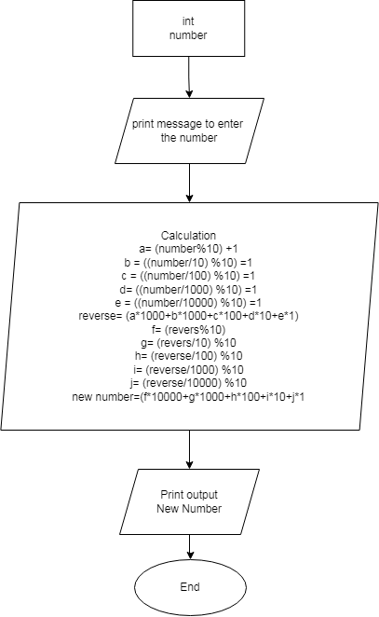

14. If cost price and selling price of an item is input through the keyboard, write a program to determine whether the seller has made profit or incurred loss. Also determine how much profit he made or loss he incurred.

Pseudo Code

Step 1: Declare the variable (cost price, selling price) to store fractional value.
Step 2: Display the message to enter (cost price, selling price).
Step 3: Taking input to variable (cost price, selling price).
Step 4: Check
if (sell price >cost price)
Step 5: calculation,
Loss= cost price-selling price;
Profit= selling price-cost price;
Step 6: print output ("The seller has made incurred loss”)
Step 7: Otherwise, print output ("The seller has made profit”)
Step 8: End.

Flow-Chart

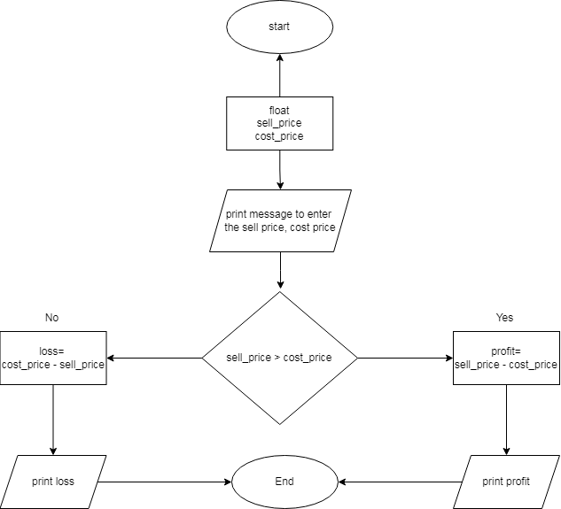

15. Any integer is input through the keyboard. Write a program to find out whether it’s an odd number or even number.

Pseudo Code

Step 1: Declare the variable (number) to store integer value.
Step 2: Display the message to enter (number).
Step 3: Taking input to variable (number).
Step 4: Check
If (number%2==0)
Step 5: Print output “The number is even”
Step 7: Otherwise,
Print output “The number is odd”
Step 8: End

Flow-Chart

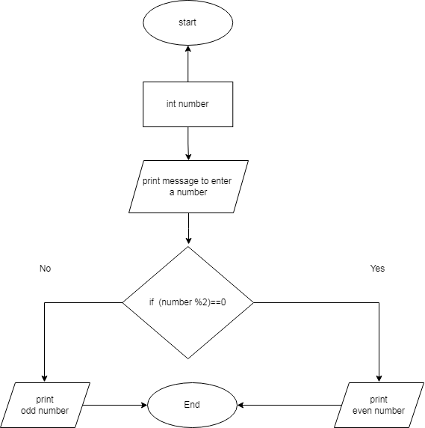

16. If the ages of Arif and Joy are input through the keyboard, write a program to determine the youngest of them.

Pseudo Code

Step 1: Declare the variable (arif age, joy age) to store integer value.
Step 2: Display the message to enter (arif age, joy age).
Step 3: Taking input to variable (arif age, joy age).
Step 4: Check
If (arif age>joy age)
Step 5: Print output “Arif is the youngest”
Step 7: Otherwise,
Print output “joy is the youngest”
Step 8: End

Flow-Chart

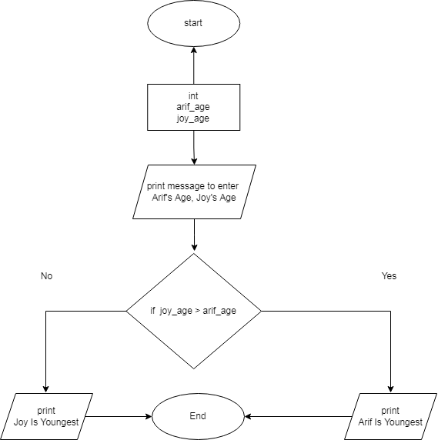

17. Write a program to check whether a triangle is valid or not, when the three angles of the triangle are entered through the keyboard. A triangle is valid if the sum of all the three angles is equal to 180 degrees.

Pseudo Code

Step 1: Declare the variable (angle_1, angle_2, angle_3) to store integer value.
Step 2: Display the message to enter (angle_1, angle_2, angle_3).
Step 3: Taking input to variable (angle_1, angle_2, angle_3).
Step 4: Check
If (angle_1+angle_1+angle_1==180)
Step 5: Print output “The triangle is valid”
Step 6: Otherwise,
Print output “The triangle is not valid”
Step 7: End

Flow-Chart

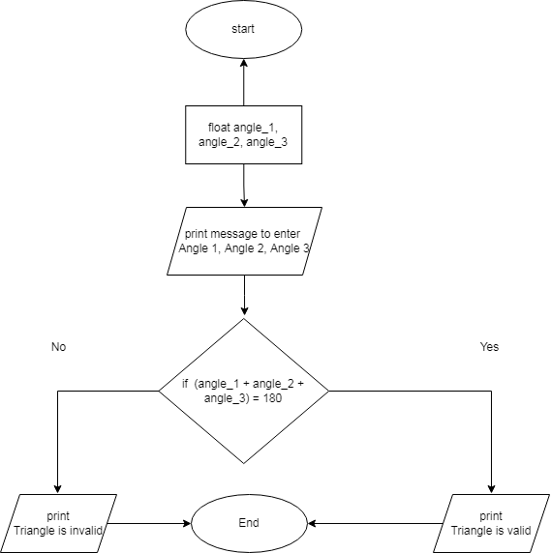

18. Write a program to check if the area of the triangle is greater than the perimeter of the triangle.

Pseudo Code

Step 1: Declare the variable (base, height, side_1, side_2, side_3) to store fractional value.
Step 2: Display the message to enter (base, height, side_1, side_2, side_3).
Step 3: Taking input to variable (base, height, side_1, side_2, side_3).
Step 4: Check
If ((0.5*base*height)> (base+side_1+side_2+side_3))
Step 5: Print output “The area of triangle is greater than the perimeter of the triangle"
Step 6: Otherwise,
Print output “The area of triangle is not greater than the perimeter of the triangle"
Step 7: End

Flow-Chart

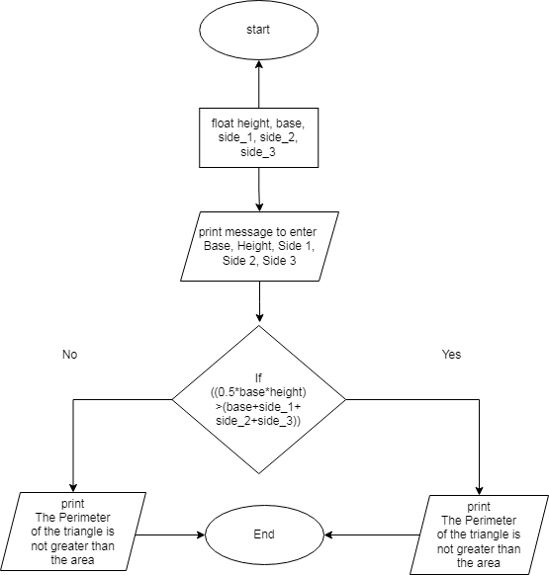

19. Write program to determine whether a number is positive or not.

Pseudo Code

Step 1: Declare the variable (number) to store fractional value.
Step 2: Display the message to enter (number).
Step 3: Taking input to variable (number).
Step 4: Check
If (num>0)
Step 5: Print output “This number is positive”
Step 6: Otherwise,
Print output “This number is not positive”
Step 7: End

Flow-Chart

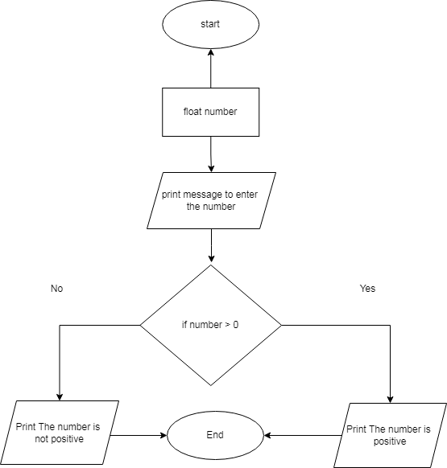

20. Write a C program to determine whether a number is negative or not

Pseudo Code

Step 1: Declare the variable (number) to store fractional value.
Step 2: Display the message to enter (number).
Step 3: Taking input to variable (number).
Step 4: Check
If (num<0)
Step 5: Print output “This number is negative”
Step 6: Otherwise,
Print output “This number is not negative”
Step 7: End

Flow-Chart

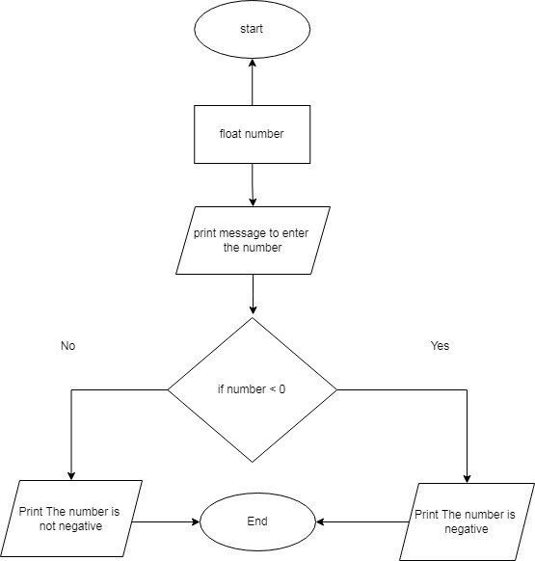

21. Write a C program to determine whether a given number is Zero (0) or not.

Pseudo Code

Step 1: Declare the variable (number) to store fractional value.
Step 2: Display the message to enter (number).
Step 3: Taking input to variable (number).
Step 4: Check
If (num==0)
Step 5: Print output “This number is zero ”
Step 6: Otherwise,
Print output “This number is not zero”
Step 7: End

Flow-Chart

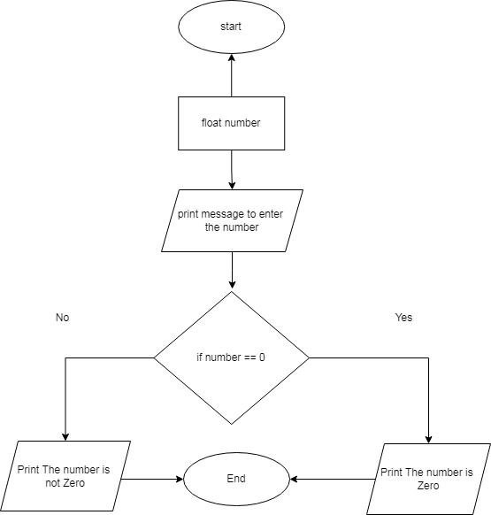

23. Imagine you want to go to the shopping complex from your home and there are two alternative routes to go there. One route is A and another one is B. In A route distance from your home to the shopping complex is 15.6 kilometers and in B route the distance is 18 kilometers. Now considering this situation write a C program to determine the shortest route to your destination.

Pseudo Code

Step 1: Declare the variable (Distance) to store fractional value.
Step 2: Display the message to enter (a,b).
Step 3: Taking input to variable (a,b).
Step 4: Check
If (a<b)
Step 5: Print output “A is the shortest route to the destination”
Step 6: Otherwise,
Print output “B is the shortest route to the destination”
Step 7: End

Flow-Chart

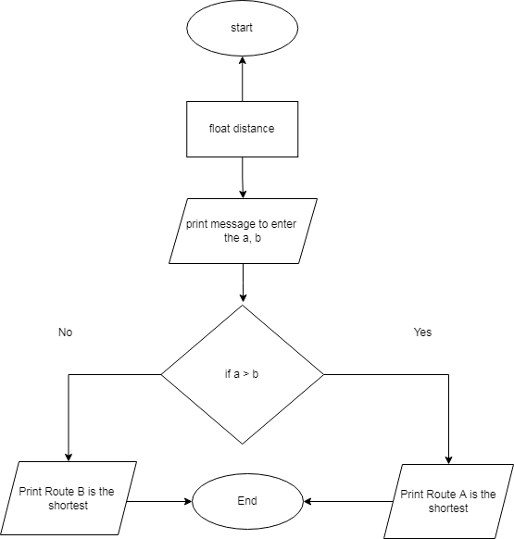

24. Write a C program that can take input a number and then decide whether the number is positive, negative or neutral.

Pseudo Code
Step 1: Declare the variable (number) to store integer value.
Step 2: Display the message to enter (number).
Step 3: Taking input to variable (number).
Step 4: Check
If (num>0)
Step 5: Print output “This number is positive”
Step 6: Otherwise,
Print output “This number is negative”
Step 7: Otherwise,
Print output “This number is neutral”
Step 8: End

Flow-Chart

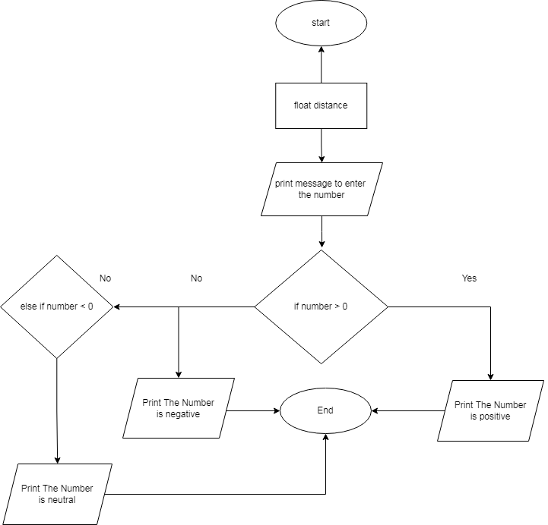

25. Write a c program to display a menu in a restaurant and input user choice.

Pseudo Code

Step 1: Declare the variable (choice) to store integer value.
Step 2: Display the Menu to Select (1.rice 2.Fish 3.Chicken 4.vegetable).
Step 3: Taking input to variable (choice).
Step 4: Check
If (choice==1)
Step 5: Print output “your food menu is rice”
Step 6: Otherwise,
If (choice==2)
Step 7: Print output “your food menu is fish”
Step 8: Otherwise,
If (choice==3)
Step 9: Print output “your food menu is Chicken”
Step 10: Otherwise,
If (choice==4)
Step 11: Print output “your food menu is vegetable”
Step 13: Otherwise,
Step 14: Print output “your food menu is not available”
Step 15: End

Flow-Chart
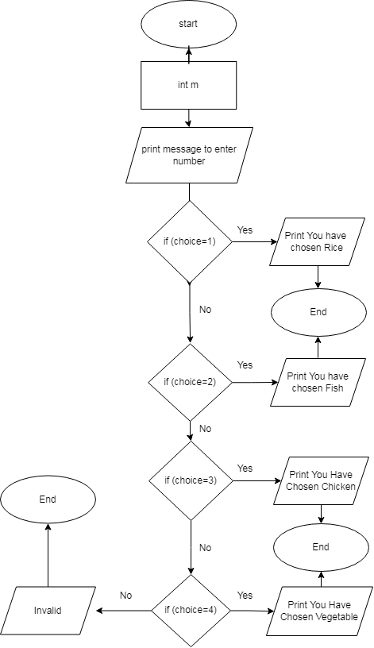
26. Write a C program to read the value of an integer m and display the value of n is 1 when m is larger than 0, 0 when m is 0 and -1 when m is less than 0.

Pseudo Code

Step 1: Declare the variable (m) to store integer value.
Step 2: Display the message to enter (number).
Step 3: Taking input to variable (m).
Step 4: Check
If (m>0)
Step 5: Print output “This number is 1”
Step 6: Otherwise,
else if(m==0)
Print output “This number is 0”
Step 7: Otherwise,
Print output “This number is -1”
Step 8: End

Flow-Chart
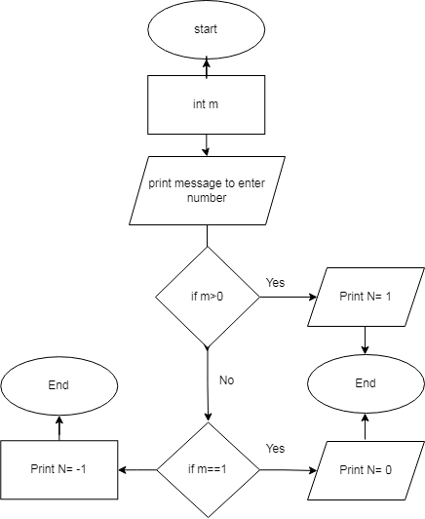

27. Write a C program to input week number and print week day.

Pseudo Code

Step 1: Declare the variable (week) to store integer value.
Step 2: Display the message to enter (week number).
Step 3: Taking input to variable (week).
Step 4: Check
If (week>=1 && week<=52);
Step 5: Print output “Saturday, Sunday, Monday, Tuesday, Wednesday, Thursday, Friday";
Step 6: Otherwise,
Print output “Invalid”
Step 8: End

Flow-Chart

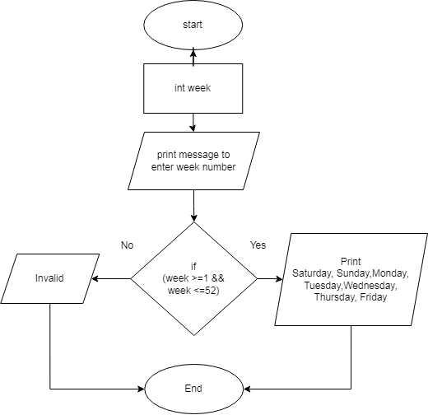

28. Write a C program to input basic salary of an employee and calculate its Gross salary according to following:
- Basic Salary <= 10000 : HRA = 20%, DA = 80%
- Basic Salary <= 20000 : HRA = 25%, DA = 90%
- Basic Salary > 20000 : HRA = 30%, DA = 95%

Pseudo Code

Step 1: Declare the variable (basic salary) to store fractional value.
Step 2: Display the message to enter (basic salary).
Step 3: Taking input to variable (basic salary).
Step 4: Check
If (basic salary <=10000)
Step 5: Print output,
“Your gross salary is =basic_salary+0.2*basic_salary+0.8*basic_salary”
Step 6: Otherwise,
else if “basic salary<=20000”
Step 7: Print output,
“Your gross salary is=basic_salary+0.25*basic_salary+0.9*basic_salary”
Step 8: Otherwise,
else if ( basic salary>20000)
Step 9: Print output,
“Your gross salary is =basic_salary+0.3*basic_salary+0.95*basic_salary”
Step 10: End

Flow-Chart
